1.1 - Patterns and Relations
We look at patterns and relationships between numbers all the time to make everyday decisions. Using our knowledge of mathematics and our problem solving skills, we can make educated choices based on a set of data.

Let’s take a look at some of the vocabulary we need to know:

Word | Definition | Examples/Picture
Divisibility rules | A set of rules that can be used to find out if a number is divisible by any number 1-10
Numerical coefficient | The number by which a variable is multiplied | 4x + 3
Constant term | The number in an expression or equation that does not change | 4x + 3
Algebraic expression | A mathematical expression containing a variable | x + 1 = 3
Relation | A variable compared to an expression that contains that variable | 10 + 6n is related to n
Linear relation | A relation whose points lie on a straight line | Graphs that has data points you can connect to form a straight line
Systematic trial | Solving an equation by choosing a value for the variable, then checking by substitution
Inspection | Solving an equation by finding the value of the variable using addition, division, subtraction, or multiplication facts

We can use patterns to determine if a given set of numbers is divisible by another number. This information can be displayed using either a Venn Diagram or a Carroll Diagram.

Venn Diagram:

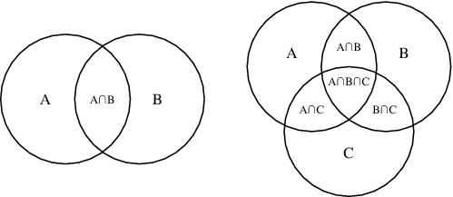

Carroll Diagram:

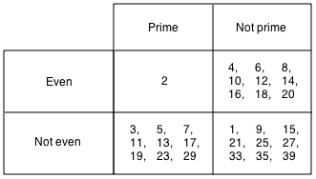

Example 1: Which of these numbers are divisible by 5? By 8? By both 5 and 8? How do you know?

12, 24, 35, 56, 80, 90, 128, 765, 1048, 1482, 3960, 15019

