5.5 – Graphs of Relations and Functions

Reminder:

A function is a relation where each value of x associates with EXACTLY ONE value of y.

The domain of a function is the set of values of the independent (x) variable.

The range of a function is the set of values of the dependent (y) variable.

Note:

When the domain is restricted to the set of discrete (whole #’s that can be counted, like # of people or age) values, the points on the graph are not connected. One way to remember this is as follows: NOT continuous, NOT connected.

Vertical Line Test

A graph represents a function when no two points on the graph lie on the same vertical line.

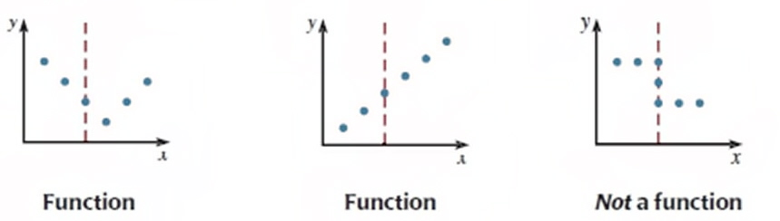

Example 1: Identifying the Graph of a Function

Which of these graphs represents a function? Justify each answer.

a) b)

Answers:

a) is a function because it passes the vertical line test; b) does not pass the vertical line test as there will be one domain value (-1) that is associated with two range values (2, -1), which violates the definition of a function

Reminder:

A dot at the end of a graph indicates that the graph stops at that point.

Example 2: Determining the Domain and Range of a Function

Determine the domain and range of each function below.

Domain: x ≤ 4 Range: y ≤ 2 Domain: -1 ≤ x ≤ 3 Range: -4 ≤ y ≤ 0

Example 3: Finding Values from the Graph of a Function

Here is a graph of the function f(x) = −2x – 4.

a) Determine the range value when the domain value is 3.
b) Determine the domain value when the range value is 6.

Answers:

There are 2 methods in which to solve this problem:

1. Using the graph
2. Using substitution

a) f(x) = −2x – 4
y = −2(3) – 4
y = −10

Note: You could also have extended the graph and drawn vertical and horizontal lines to find this value.

b) f(x) = −2x – 4
(6) = −2x – 4
10 = −2x
x = −5

