5.6 – Properties of Linear Relations

The graph of a linear relation is a straight line. We can identify a linear relation using:

a) a table of values

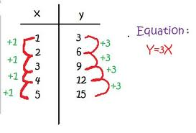

For a linear relation, when the changes in the 1st column are the same from one row to the next, the changes in the 2nd column are the same. If they are not the same, it is not a linear relation.

b) a set of ordered pairs

{ (0 , 25) , (10 , 40) , (20 , 55) , (30 , 70) }

c) a graph

We can use each representation to calculate the rate of change. The rate of change is constant for a linear relation, and is the numeric value multiplied by the independent variable (ie. the slope) in any linear equation of the form y = mx + b. It can be expressed as:

$$\frac{change in dependent variable}{change in independent variable} = \frac{Δy}{Δx} = \frac{y2-y1}{x2-x1}$$

Example 1: Determining whether a Table of Values Represents a Linear Relation

Does the table below represent a linear relation? Justify your answer.

Example 2: Determining whether an Equation Represents a Linear Relation

Does the equation below represent a linear relation? Justify your answer.

y = –x – 2

X | Y
0 | -2
1 | -3
2 | -4
3 | -5
4 | -6

Example 3: Finding the Rate of Change from a Graph

Example 4: Identifying a Linear Relation

A new car is purchased for $24,000. Every year, the value of the car decreases by 15%. The value is related to time.

Time (yrs) | Value ($)
0 | 24,000
1 | 20,400
2 | 17,340
3 | 14,739

