6.1 – Slope of a Line

The slope of a line segment is a measure of its rate of change.

Rate of Change = $\frac{change in dependent variable}{change in independent variable} = \frac{Δy}{Δx} = \frac{y2 - y1}{x2 - x1} = \frac{rise}{run}$ = Slope

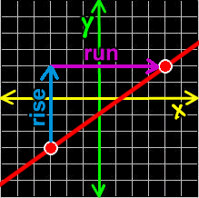

There are 4 types of possible slopes:

1. Positive – both x and y increase or decrease; also known as increasing
2. Negative – either x or y decrease; also known as decreasing
3. 0 – any horizontal line segment
4. Undefined – any vertical line segment

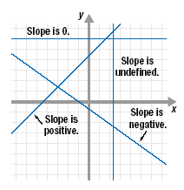

The slopes of all segments on a line are equal – the lengths of the legs of the triangles would have the same ratio and hence are similar.

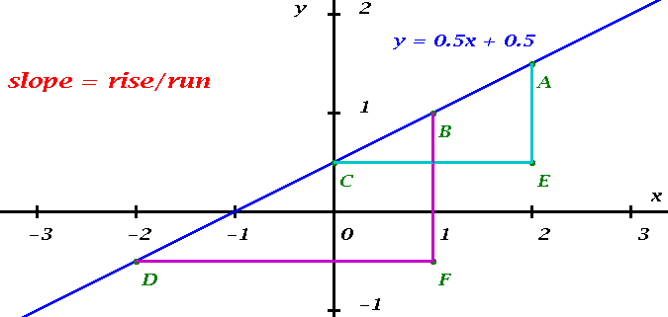

Example 1: Determining the Slope of a Line Segment

Determine the slope of the line segment.

Example 2: Drawing a Line Segment with a Given Slope

Draw a line segment with a slope of -1.

Example 3: Determining Slope Given Two Points on a Line

Determine the slope of the line that passes through A(-2, 1) and B(4, 8).

Example 4: Interpreting the Slope of a Line

Construction workers are paving a road. The road must drop 4-cm for every 650-cm moved horizontally.

a) What is the slope of the line?

b) Suppose a section of the road drops 24.5-cm. How long is this section of the road measured horizontally?

