Area of a Circle
Suppose a circle was cut into equal sections and then arranged to approximate a parallelogram. The more congruent sectors we use, the closer the area of the parallelogram is to the area of the circle, and the more the shape looks like a rectangle.

The sum of the two longer sides is equal to the circumference, C. So each longer side, or the base of the rectangle, is one-half the circumference of the circle, or $\frac{C}{2}$.

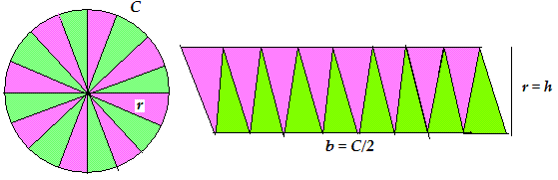
But $C=2πr$

So, the base of the rectangle = $\frac{2πr}{2}$
= $πr$

Each of the two shorter sides is equal to the radius, r.

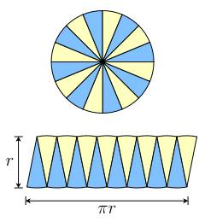

The area of the rectangle, which is made up of all the sectors of the circle, is: base x height.
The base is $πr$ and the height is r. So the area of the rectangle is: $πr$ x r = $πr$².

Since the rectangle is made from all sectors of the circle, the rectangle and the circle have the same area.

Area of Circle:

A = $πr$²

