Area of a Parallelogram and Triangle
Any side of a parallelogram is a base of the parallelogram. The height of a parallelogram is the length of a line segment that joins parallel sides and is perpendicular to the base.

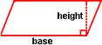

Recall that both a rectangle and a square are parallelograms.

Any parallelogram that is not a rectangle can be “cut” and rearranged to form a rectangle.

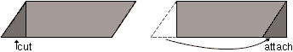

The parallelogram and the rectangle have the same area. The area of a parallelogram is equal to the area of a rectangle with the same height and base. To find the area of a parallelogram, multiply the base by the height.

Area of rectangle: Area of parallelogram:

A = bh A = bh

When we draw a diagonal in a parallelogram, we make two congruent triangles. Congruent triangles have the same area. The area of these two triangles is equal to the area of the parallelogram that contains them.

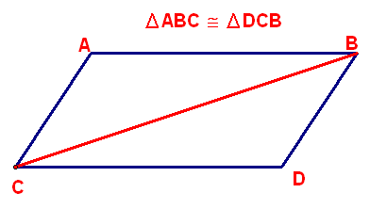

Area of parallelogram: Area of triangle:

A = bh $A= \frac{bh}{2}$

