Interpreting and Drawing Circle Graphs

A circle graph is a diagram that uses parts of a circle to display data. The information is shown as parts of one whole.

Each part, called a sector, of a circle graph represents a percent of the whole circle. The whole circle represents 100%.

A circle graph has a title. Each sector is labeled with a category and a percent. A circle graph compares the number in each category to the total number. That is, a fraction of the circle represents the same fraction of the total.

Sometimes, a circle graph has a legend that shows what category each sector represents.
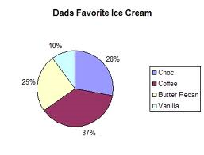
A percent circle is divided into 100 congruent or equal parts. Each part is 1% of the whole circle. You can draw a circle graph on a percent circle.
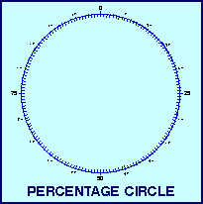

Each piece of data is written as a fraction of the whole. Each fraction is then written as a percent. Sectors of a percent circle are coloured to represent these percents.

A central angle is the angle between the two radii that form a sector of a circle. The sum of the central angles is 360°. A central angle is also called a sector angle.
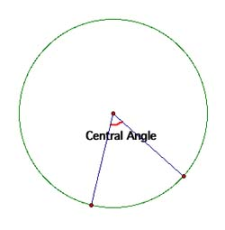
Example 1

All the students in Grade 7 were asked how they get to school each day. Here are the results: 9 rode their bikes, 11 walked, 17 rode the bus, and 13 were driven by car. Construct a circle graph to illustrate these data.

Step 1: For each type of transport, write the number of students as a fraction of 50, the total number of students.

Step 2: Convert each fraction into a decimal and percent. Their sum should be 1 and 100%.

Step 3: To find the sector angle for each type of transport, multiply each decimal by 360.

Step 4: Construct a circle using a compass. Use a protractor to make each sector angle, starting with the smallest angle. Label each sector with its name and percent. Write a title for the graph.

