Investigating Circles
All points on a circle are the same distance from the centre of the circle. This distance is the radius of the circle.

The longest segment in any circle is the diameter of the circle. The diameter passes through the centre of the circle. The diameter is two times the length of the radius, or the radius is one-half the length of the diameter.

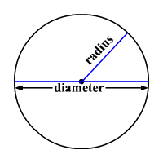

Let r represent the radius, and d the diameter. Then the relationship between the radius and diameter of a circle is:

d = 2r

Example 1: A circle has a diameter of 3.8 cm. What is the radius?

Example 2: A circular tabletop is to be cut from a rectangular piece of wood that measures 1.4 m by 1.8 m. What is the radius of the largest tabletop that could be cut? Justify your answer.

